RIHAM AHAMED ABDUL RAHEEM

HND COMPUTING IDM

SWOT Analysis

Contents

Introduction 1

SWOT Analysis 1

Definition 1

Benefits 2

Considerations 2

Warning 2

Implementation 2

SWOT Analysis of the ecommerce industry 3

Strength 3

Accessibility: 3

Low price: 3

For the organization: 4

Weakness 4

Industry specific: 4

For the organization: 4

Opportunities 5

Growing market 5

Influencers 5

For the organization: 6

Threats 6

Competition: 6

Fraud: 6

Data concerns: 7

Monopolies: 7

For the organization: 7

Conclusion 8

References 9

**List of figure**

Figure 1: SWOT Analysis 1

Figure 2: Strength 3

Figure 3: Weakness 4

Figure 4: Opportunities 5

Figure 5: Threat 6

# Introduction

Once you have set a goal for your company or a specific project, SWOT analysis can help determine if this is a good idea to move forward. By analyzing carefully, you can avoid costly mistakes. You should SWOT as a group to get as many comments as possible. (McCormick, 2021)

# SWOT Analysis

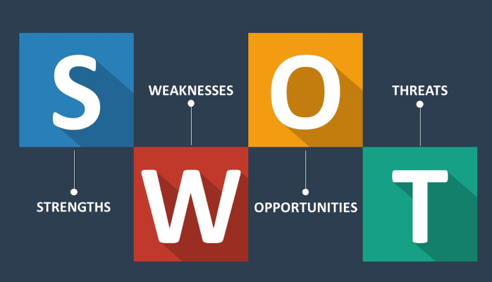

Figure : SWOT Analysis

## Definition

SWOT stands for Strengths, Weaknesses, Opportunities, and Threats. When a business plans its next move, it should consider all of these things before proceeding. The strengths and weaknesses of the plan are factors that are under the control of the company. The company can work to maximize its strengths and eliminate weaknesses. On the other hand, opportunities and threats are external factors of the community that can affect the success of the project. The company does not have much control over these situations.

## Benefits

SWOT analysis of a particular idea means that all aspects of the project need to be carefully considered. This allows you to evaluate the success of the project before investing a lot of time and capital. It will also give you confidence that you are on the right track.

## Considerations

SWOT works best when combining different views. Train everyone involved in the program on SWOT ideas and brainwashing to identify the strengths, weaknesses, opportunities, and threats of the project. For example, a programmer may indicate whether the current programming team has the skills needed to complete the job - strength or weakness - and a sales representative may have additional insight into what the competition is doing - a possibility or weakness.

## Warning

For the SWOT technique to work within your organization, everyone must be honest, especially about the weaknesses of the company. It may be tempting to say that your department can handle the task, but the truth is, if you do not have the manpower to take it on, the plan is doomed. Dishonesty will result in false protection from SWOT.

## Implementation

If you want to use the SWOT analysis method in your organization, it is essential that all employees understand its importance and implementation. One way to do this is to hire a company to give a presentation on the techniques. From this point of view, you can be sure that everyone is on the same page.

(McCormick, 2021)

# SWOT Analysis of the ecommerce industry

The meaning of SWOT

S - Strength

W - Weakness

O - Opportunities

T - Threats

## Strength

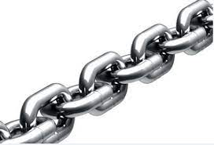Here are two major strengths of eCommerce:

Figure : Strength

### Accessibility:

The biggest strength of e-commerce companies is their wide accessibility. In the past, shopping meant traveling physically to a specific place within hours. With e-commerce, shoppers can now browse, view, and buy from the comfort of their own homes at any time of the day (or night). While telescopes offer similar benefits, the advent of the Internet has diverted a large number of consumers from television, radio, and magazines to computers.

### Low price:

Another significant strength of online shopping is that the products are cheaper compared to traditional retail channels. One reason for this is that e-commerce usually involves sellers interacting directly with consumers, eliminating intermediaries such as distributors. Another reason is that e-commerce stores generally have significantly lower overheads than brick-and-mortar stores, which should take into account rental costs, employee salaries, and more.

### For the organization:

* The Royal Furnishers (Pvt) Ltd is one of the leading manufacturers of “Quality Furniture” in Sri Lanka.
* With a workforce of highly skilled personnel, which include designers, carpenters, spray painters, quality controllers plus a dedicated sales service team.
* Low Staff cost
* 24hours work

## Weakness

The great weakness of the strange industry is:

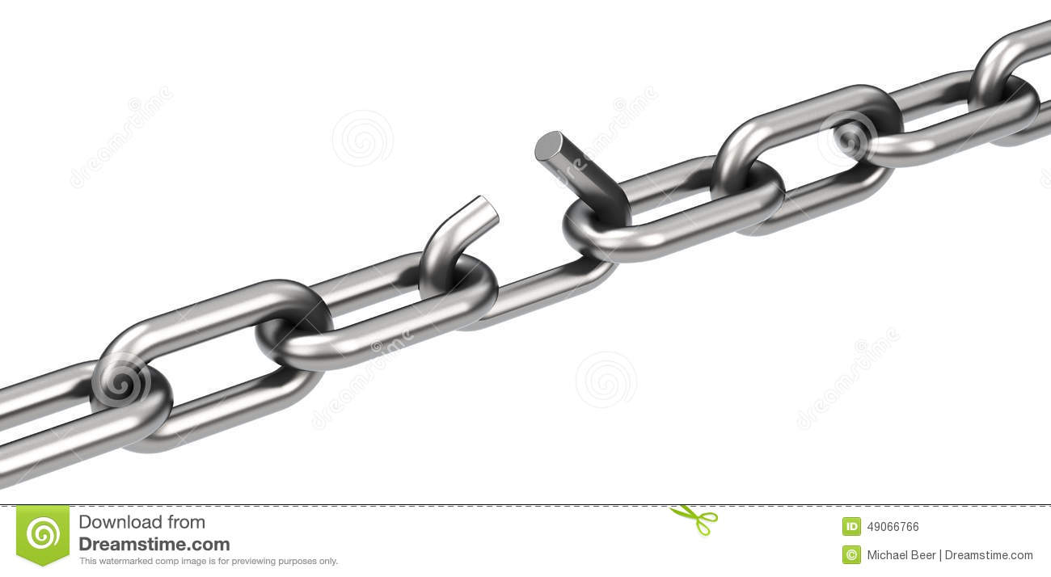

Figure : Weakness

### Industry specific:

Some products lend themselves more to e-commerce than others. For example, books, electronics, and kitchen utensils are easy to sell through an online store because consumers are almost aware of what to expect. However, some articles are much less universal; The best example of this is clothing. It is difficult for consumers to buy the clothes they want online because they do not know if they will fit, what they will look like, and what they will look like. Unfortunately, e-commerce stores can be very difficult to expand in these industries.

### For the organization:

* Lack of adequate knowledge about eCommerce
* Security problem
* Lack problem consumer site and company site

## Opportunities

Here are two opportunities for eCommerce:

Figure : Opportunities

### Growing market

One of the biggest opportunities for the online shopping industry is the growing market. While most consumers in developed countries already have electronic devices, many consumers in developing countries do not, and as a result do not buy products online. As the prices of electronic goods continue to fall, we are seeing an increase in the number of potential buyers online. This will then lead to higher e-commerce sales volume.

### Influencers

Different internet users use their social followers to promote various products and services. These people, known as influencers, offer a powerful marketing opportunity to interested e-commerce marketers. As social media becomes an important part of our daily lives, influencers are increasingly ready to play a key role in how products are marketed, and e-commerce stores are in a better position to take advantage of this.

### For the organization:

* Royal furniture (Pvt) Ltd. A company that is well known and leading in Sri Lanka, so it is more likely that consumers will come to the eCommerce website.
* visiting of customers from other country
* New Technology

## Threats

Here are four major threats for eCommerce:

Figure : Threat

### Competition:

While the low barrier to entry into the e-sector is a strength, on the one hand, it is also a significant threat to existing marketers. This is because of how easy it is for almost anyone, anywhere, to start a new eCommerce store and compete with other online shopping businesses. It is important to know that this element of competition does not affect the overall success of the e-commerce sector, but rather affects individual companies.

### Fraud:

Whether it is credit or debit cards, bank transfers, or cryptocurrencies, the e-commerce world is driven by digital payments. It has become a great target for fraudsters and is now the easiest way to make money for their illegal activities. Scammers can buy products online using other people’s payment details and, when completely anonymous, send those items to nearby doors, where they will be sent while the owner is working. Unfortunately, combating fraud on the Internet is incredibly difficult, posing a major threat to the industry.

### Data concerns:

Apart from blatant fraud, online shopping is more likely to get worse, especially when it comes to user data. You will need to provide a large amount of confidential data including your payment details, address, and other classified information for online purchases. If this information gets into the wrong hands, it can have disastrous consequences. In addition, since the introduction of new data-related regulations such as the EU's GDPR, there have been new issues in data-related aspects of conducting online business.

### Monopolies:

Since e-shops can serve entire countries or even the whole world, this leaves a lot of potentials for monopolies to form. The best example of this is when you look at how Amazon has affected bookstores. In the past, a variety of local bookstores (including mom and dad stores, small chains, and large chains) would have served a specific area. With the advent of great e-commerce alternatives like Amazon, these stores are disappearing and Amazon is becoming the only place for books. This trend could spread to other markets, sometimes justifying government regulation.

(Bush, 2019)

### For the organization:

* The difficulty of introducing their webpage among consumers
* Frauds of fellow thieves
* Fake customers
* Many websites in related company

# Conclusion

Overall, the eCommerce industry is in a strong position, but it certainly faces some drawbacks. Its strengths include affordability and low price, which allows customers to buy where and when at a cheaper price than usual. The main weakness of online shopping is that some businesses (such as clothing) do not lend because consumers cannot afford to try before.

Looking ahead to the future of Royal Furniture (Pvt) Ltd Online Shopping SWOT Analysis, the opportunities for e-commerce include the growing digital market and the power of Internet influencers. but Many threats need to be monitored and fixed, including competition, fraud, data theft, and the potential for monopolies.

# References

Bush, T., 2019. *SWOT Analysis of the eCommerce Industry.* [Online]   
Available at: https://pestleanalysis.com/swot-analysis-of-ecommerce-industry/  
[Accessed 16 April 2021].

McCormick, M., 2021. *The Introduction of SWOT Analysis.* [Online]   
Available at: https://smallbusiness.chron.com/introduction-swot-analysis-4745.html  
[Accessed 16 April 2021].